GROUP 33 – GROUP REPORT

Team members:

* Jake Barr
* James Lee
* Jiajun Liu
* Owen Norman
* Angelos Tsoutsas
* Eduardo Diaz-Rio
* Mohammed Khan
* Makhmud Abdulkerimov

Statement of Relative Contribution

|  |  |  |  |
| --- | --- | --- | --- |
|  | Design, Planning and Coordination | Coding and Testing | Other |
| Jake Barr | 20% | 20% | TBA |
| James Lee | 20% | 17% | TBA |
| Jiajun Liu | - | TBA | TBA |
| Owen Norman | 20% | 15% | TBA |
| Angelos Tsoutsas | - | 7% | TBA |
| Eduardo Diaz-Rio | 20% | 10% | TBA |
| Mohammed Khan | - | - | TBA |
| Makhmud Abdulkerimov | 20% | 20% | TBA |

These percentages were agreed during an in-person team meeting where all team members were presented and all discussed and agreed on said percentages. Below lies each persons signature to show their agreement to the percentages:

|  |
| --- |
| Jake Barr |
| James Lee |
| Jiajun Liu |
| Owen Norman |
| Angelos Tsoutsas |
| Eduardo Diaz-Rio |
| Mohammed Khan |
| Makhmud Abdulkerimov |

Technical Documentation

Main components

There are 3 sections to our program, the Order UI, the Waiter UI, and the Kitchen UI.

Order UI

This is the section where customers will be ordering from. Once entered the customer will be presented with a variety of submenus, from Burgers to Kebabs and more. The customer will be free to navigate each submenu and add anything the like to their basket. We have made each menu item into a card, which contains a picture of the food, the name, price, and an information button containing any allergic information customers might need. The price also doubles backs as a button that when pressed adds said item to the basket. As seen below the submenus are displayed on the left-hand side for easy traversal and if the customer is ever in need of assistance there is a Help button at the bottom that will alert a staff member. Before the customer proceeds to check out, they must enter the table number, using the button and box on the top right, so that the staff know where to take their food. This was done since the customers will be using portable devices provided by the restaurant and these devices would be moved around frequently and so rather than having to keep track where each device goes, we made the customer do it and speed up the process. Finally, once the customer has added everything, they will procced to the checkout area.

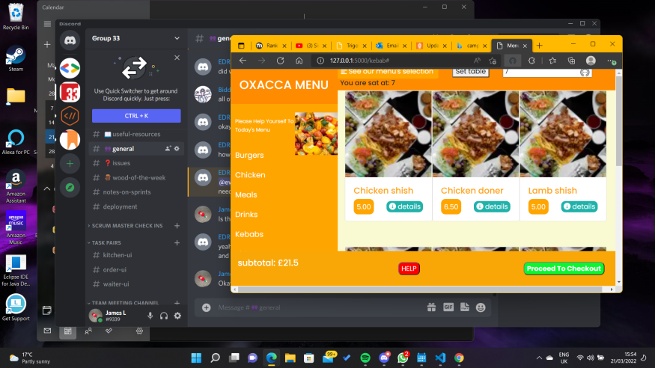

In the checkout area, seen below, the user will be able to see what they have ordered and can remove any items they no longer want and have the ability to go back to order anything else they might want. Once they have checked that is everything they want, they will be able to press PAY and the order will be sent.

Waiter UI

The waiter’s role in the system is to interact with orders and deal with the tables. The waiter must log in into their account before they interact with the system, this is so customer don’t enter this UI by accident. As seen below the waiter can see the table status and see if they are: going to order, waiting for their food, and have paid and left. And with said status the waiter using the till can assign the waiters to certain tables and change the status. We have displayed the tables on the screen and made them interactable via click to change the status(colour) of the table. The second aspect of the UI is the interaction of customer orders, the waiter will receive any orders made by the customers. We have made cards, like in Order UI, where each order is given a number and the waiter uses the buttons given to confirm or cancel. The waiter can add and remove items to it if a customer asks for it but forgot to put it in themselves and they can cancel the order outright. They can do it via entering the order number, the item, and the quantity on the input boxes on the top left.

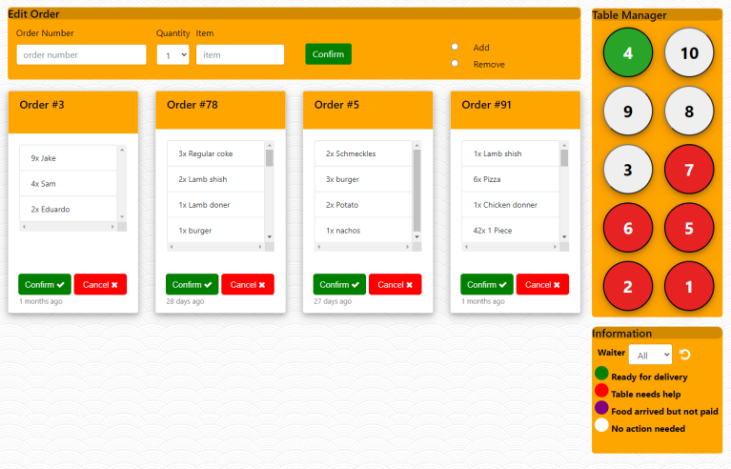

Kitchen UI

- View Orders to be Prepared - View Orders ready for delivery - Mark orders as delivered - Search for Orders with Ready and Preparing statuses - Toggle orders to signify an order being worked on

The main use of the Kitchen UI is to interact with incoming orders and to separate them depending on if they are: prepared, ready for delivery, delivered and being worked on. The head chef will be the person interacting with the program as he will be the one telling people what to do in terms of orders. To make it as easy and user-friendly as possible, given he hectic scene of a kitchen, we made it so the orders will be organized in cards with a button at the bottom of the card that will change the status when pressed. To keep better track of the orders we separated them orders into preparing and ready so to make it easier for the staff to know what needs making and what orders the waiters can take. We also added a search bar so if a customer asks for an update on their order or something went wrong they can find it as fast as possible.

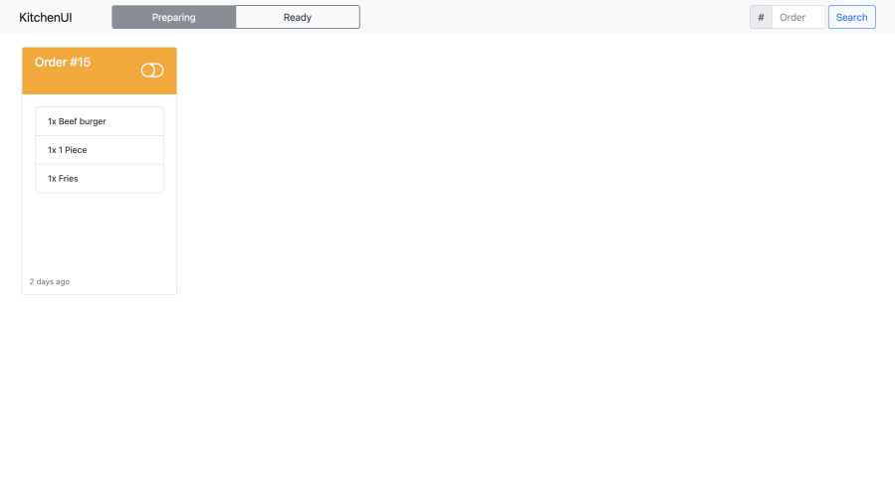

Packages

Completed User Stories

* As a waiter, I want to be able to enter orders and produce bills.
* As a customer, I don’t want my order to be lost.
* As an owner, I want a good authentication system to prevent outsiders from tampering with orders and data.
* As a customer, I want an order UI that is easy to use
* As a waiter, I want an easier to deal with customer issues.
* As a waiter, I want an easy way to learn the menu
* As a waiter, I want to be able to easily communicate with kitchen staff

Movie clip